Workshop leaders.

Economics: Manuel Fernandez

History : Brian Mimmack

Mathematics : Sheila Messer

June 2004

Programme (provisional)

Day time event location

Sunday 27  June | 10.00 – 17.00 | Arrival | 139 Banbury Road
Sunday 27  June | 18.00 | Welcome reception | Function room new place
Sunday 27  June | 19.00 | Welcome address
Sunday 27  June | 19.30 | Dinner | Dining room
Monday 28  June | 08.00 – 09.00 | Breakfast | Dining room
Monday 28  June | 09.00 – 10.30 | Input session 1 | Economics N23, History N14, Maths N22
Monday 28  June |  | Coffee | Staff room
Monday 28  June | 11.00 – 12.30 | Input session 2 | Economics N23, History N14, Maths N22
Monday 28  June |  | Lunch | Dining room
Monday 28  June | 13.30 – 15.00 | Input session 3 | Economics N23, History N14, Maths N22
Monday 28  June |  | Coffee
Monday 28  June | 15.30 – 18.00 | Publishers exhibition | Library
Monday 28  June | 18.30 | Evening meal
Monday 28  June | 19.30 | Key note address  Peter Oppenheimer | Library
Tuesday 29  June | 08.00 – 09.00 | Breakfast | Dining room
Tuesday 29  June | 09.00 – 10.30 | Input session 4 | Economics N23, History N14, Maths N22
Tuesday 29  June |  | Coffee | Staff room
Tuesday 29  June | 11.00 – 12.30 | Input session 5 | Economics N23, History N14, Maths N22
Tuesday 29  June |  | Lunch
Tuesday 29  June | 13.30 – 15.00 | Input session 6 | Economics N23, History N14, Maths N22
Tuesday 29  June |  | Coffee | Staff room
Tuesday 29  June | 16.00 – 18.00 | Ashmolean museum | City Centre
Tuesday 29  June | 18.30 | Evening meal
Tuesday 29  June | 19.30 | Oxford walking tour | City/Colleges
Wednesday 30 June | 09.00 – 10.30 | Keynote Speaker  Robin Wilson | Economics N23, History N14, Maths N22
Wednesday 30 June |  | Coffee | Staff room
Wednesday 30 June | 11.00 – 12.30 | Input session 5 | Economics N23, History N14, Maths N22
Wednesday 30 June |  | Lunch
Wednesday 30 June | 13.30 – 15.00 | Input session 6 | Economics N23, History N14, Maths N22
Wednesday 30 June | 17.30 – 18.30 | Farewell Barbeque | St Clare’s Garden
 | 19.30 - 21.30 | Punting expedition | Cherwell Boat house
 | 22.00 | Farewell drinks reception | Staff room
 | 8.00 – 9.00 | Breakfast | Dining room
Thursday 1
July

Detailed agendas for each workshop will be available directly from the workshop leader and the website.

www.stclares.ac.uk/ibinstitute

Arrival 10.00 - 17.00

Please report to 139 Banbury Road in order to register and receive directions to accommodation.

Getting to Oxford:

By Road:

Oxford is well connected to the UK motorway network by the A40 and the A34 trunk roads. St Clare’s is in North Oxford, close to Summertown. If approaching Oxford at peak times it is best to avoid the city centre as it does become congested.

St Clare’s is on a number of regular bus routes which give easy access to the city centre

By Rail:
Regular train services from London and from the North of the UK. Buses run regularly to Summertown via Banbury road – where the main St Clare’s site is located.

By Air:
Regular bus services run from Heathrow and Gatwick to Oxford see : www.theairline.info

Local buses or taxis can then be used for transfer to St. Clare’s.

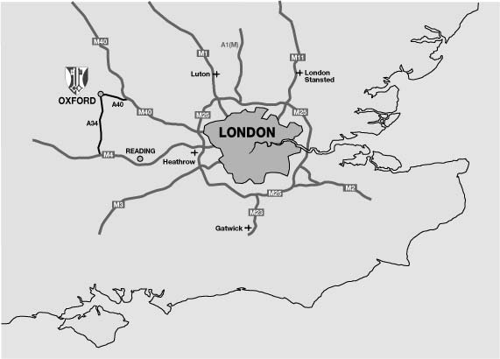

Getting to St Clare’s

Banbury road runs approximately north – south from the city centre. The bus service 2A runs from the station past St Clare’s. The main reception for teachers’ courses will be at the 139 Banbury road buildings. Most visiting teachers will be accommodated in Logan , house or the houses in Staverton and Lathbury road.

Parking at 139 Banbury Road is very limited. If arriving by car, park temporarily in Lathbury road until accommodation is allocated. Off road parking is available at all the student houses.

