Workshop leaders.

Chemistry - Nick Lee
Physics – Keith Ord
Biology - Jonathan Knopp
English A1 - Elizabeth Stephan

June 2004

Programme

Day time event location

Sunday 20  June | 10.00 – 17.00 | Arrival | 139 Banbury Road
Sunday 20  June | 18.00 | Welcome reception | Function room new place
Sunday 20  June | 19.30 | Welcome dinner | Dining room
Monday 21  June | 08.00 – 09.00 | Breakfast | Dining room
Monday 21  June | 09.00 – 10.30 | Input session 1 | Chemistry N22, Biology N11, Physics B11, English A1 N14
Monday 21  June |  | Coffee | Staff room
Monday 21  June | 11.00 – 12.30 | Input session 2 | Chemistry N22, Biology N11, Physics B11, English A1 N14
Monday 21  June |  | Lunch | Dining room
Monday 21  June | 13.30 – 15.00 | Input session 3 | Chemistry (history of Science museum), Biology N11, Physics B11, English A1 N14
Monday 21  June |  | Coffee | Staff room / Blackwells
Monday 21  June | 15.30 – 18.00 | Oxford walking tour | Colleges / Blackwells
Monday 21  June | 18.30 | Evening meal
Monday 21  June | 19.30 | Presentation  Mina Patel | Library - multimedia science school training/demonstration
Tuesday 22  June | 08.00 – 09.00 | Breakfast | Dining room
Tuesday 22  June | 09.00 – 10.30 | Input session 4 | Chemistry N22, Biology N11, Physics B11, English A1 N14
Tuesday 22  June |  | Coffee | Staff room
Tuesday 22  June | 11.00 – 12.30 | Input session 5 | Chemistry N22, Biology N11, Physics B11, English A1 N14
Tuesday 22  June |  | Lunch
Tuesday 22  June | 13.30 – 15.00 | Input session 6 | Chemistry, Biology N11, Physics B11, English A1 N14
Tuesday 22  June |  | Coffee | Staff room
Tuesday 22  June | 16.00 – 18.00 | Hodder Murray publisher’s exhibition | Library
Tuesday 22  June | 18.30 | Evening meal
Tuesday 22  June | 19.30 | Key note address  Kevin Purday | Llbrary
Wednesday 23  June | 09.00 – 10.30 | Input session 4 | Chemistry N22, Biology N11, Physics B11, English A1 N14
Wednesday 23  June |  | Coffee | Staff room
Wednesday 23  June | 11.00 – 12.30 | Input session 5 | Chemistry N22, Biology N11, Physics B11, English A1 N14
Wednesday 23  June |  | Lunch
Wednesday 23  June | 13.30 – 15.00 | Input session 6 | Chemistry , Biology N11, Physics B11, English A1 N14
 | 17.30 – 18.30 | Farewell Barbeque | St Clare’s Garden
 | 19.30 - 21.30 | Punting expedition | Cherwell Boat house
 | 22.00 | Farewell drinks reception | Cherwell Boat house
Thursday 24  June | 8.00 – 9.00 | Breakfast | Dining room

Detailed agendas for each workshop will be available directly from the workshop leader and the website.

www.stclares.ac.uk/ibinstitute

Arrival 10.00 - 17.00

Please report to 139 Banbury Road in order to register and receive directions to accommodation.

Getting to Oxford:

By Road:

Oxford is well connected to the UK motorway network by the A40 and the A34 trunk roads. St Clare’s is in North Oxford, close to Summertown. If approaching Oxford at peak times it is best to avoid the city centre as it does become congested.

St Clare’s is on a number of regular bus routes which give easy access to the city centre

By Rail:
Regular train services from London and from the North of the UK. Buses run regularly to Summertown via Banbury road – where the main St Clare’s site is located.

By Air:
Regular bus services run from Heathrow and Gatwick to Oxford see : www.theairline.info

Local buses or taxis can then be used for transfer to St. Clare’s.

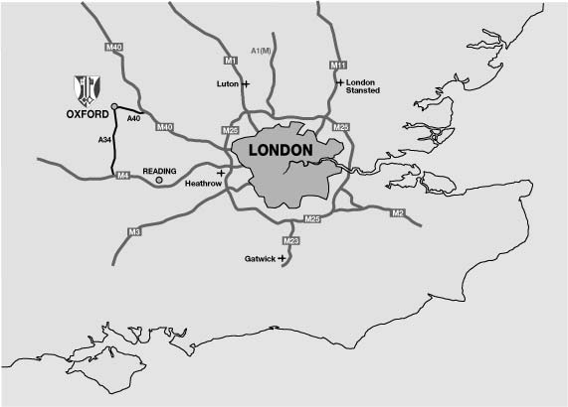

Getting to St Clare’s

Banbury road runs approximately north – south from the city centre. The bus service 2A runs from the station past St Clare’s. The main reception for teachers’ courses will be at the 139 Banbury road buildings. Most visiting teachers will be accommodated in Logan , house or the houses in Staverton and Lathbury road.

Parking at 139 Banbury Road is very limited. If arriving by car, park temporarily in Lathbury road until accommodation is allocated. Off road parking is available at all the student houses.

