Child Protection Policy

Section 1

St. Clare’s, Oxford recognises its responsibility for safeguarding and promoting the welfare of Children. We seek to establish a safe and nurturing environment free from discrimination or bullying.
This policy applies to the whole of St. Clare’s workforce including volunteers and governors.

We recognise that because of their day-to-day contact with children, College staff are ideally placed to observe the outward signs of abuse.
Staff will therefore:
- Report any concerns to the Child Protection Officer – Tom Walsh (Vice Principal).
- Establish and maintain an environment where children feel secure, are encouraged to talk and are listened to.
- Ensure that students know that they can approach any adult in College if they are worried and they will receive a consistent supportive response.
- Include in the curriculum, opportunities for students to develop the skills they need to recognise and stay safe from abuse.

St. Clare’s undertakes to:

- Follow the Oxfordshire Safeguarding Children's Board (OSCB http://www.oscb.org.uk/wps/wcm/connect/occ/oscb/professionals) procedures in all cases of abuse, or suspected abuse and have regard to the statutory obligations placed on us by Section 175 of the 2002 Education Act.

- Ensure this policy and our practice are consistent with the requirements of Working Together to Safeguard Children (HM Government 2010) and Safeguarding Children and Safer Recruitment in Education (HM Government 2007).

- Ensure that we have a designated member of staff for child protection (and inform the Schools Safeguarding Team Administrators on 01865 810603 or 01865 810610 when this changes).

- Ensure that the designated member of staff receives appropriate training (child protection and inter-agency work updated every 2 years) approved by the OSCB and that this training is disseminated to all others in the school in line with statutory requirements.

- Ensure that all staff have training in child protection (with refresher training every 3 years). Part-time and voluntary staff who work with children are to be made aware of the arrangements. All newly appointed staff and volunteers will have induction training.

- Ensure that all staff (volunteers etc), have been appropriately checked for their suitability through the Safe Recruitment procedures (see Safeguarding Children and Safer Recruitment in Education (HM Government 2007)).

- Ensure that all staff and volunteers understand their responsibilities in being alert to, and acting appropriately in, cases of abuse or suspected abuse.

- Ensure that Senior Managers and Governors of St. Clare’s, Oxford will undertake an annual review of the school’s child protection policies and procedures and of the efficiency with which the related duties have been discharged to ensure our College is aware of the most recent expectations and will act to remedy any deficiencies in our policies without delay.

- Establish and maintain links with relevant agencies and co-operate as required with enquiries of a child protection nature.

- Keep accurate written records of concerns on students even where referral is not appropriate immediately.

- Ensure that all child protection records are kept secure and confidential and separate from the main student file.

- Ensure that all staff, governors, volunteers understand that there is a procedure to be followed in dealing with allegations made against teaching and non-teaching staff. This procedure must be followed on all occasions (see chapter 5 of Safeguarding Children and Safer Recruitment in Education (HM Government 2007) available from the Child Protection Officer). See Annex 1 to this policy.

- In cases where a member of boarding staff is suspended pending investigation of a child protection nature arrangements will be made for alternative accommodation away from students.

- Report to the Disclosure and barring Service, within one month of leaving the school any person (whether employed, contracted, volunteer or student) whose services are no longer used because he or she is considered unsuitable to work with children.

- Ensure that this policy is reviewed annually and is in line with Oxfordshire's OSCB procedures.

It is noted that the provisions of Section 175 of the Education Act, place a general duty on school to safeguard and promote the welfare of children in our care and, as such, staff will adhere to other related school policies, i.e. Behaviour Policy, Anti-bullying Policy, Health and Safety etc.

As part of their induction training all new members of staff at St. Clare’s receive child protection training. This includes explanation of this policy.

Section 2

THE KEY POINTS TO FOLLOW IF YOU SUSPECT, OR ARE TOLD OF, ABUSE

It is a requirement of the Children Act (1989) and the National Minimum Standards for Boarding Schools (2002, updated 2011) that adults looking after children (those under the age of 18) in St Clare’s, Oxford should be aware of the risks of abuse (by adults or other young people), and take steps to reduce those risks. They should know what to do if they suspect that someone is being physically or sexually abused, or if someone tells them that this happening. This includes physical and sexual abuse that is occurring in College, or to a student of St Clare’s at home or outside the College.

The following key points give a guide on what to do and not to do:

- Always stop and listen straight away to someone who wants to tell you about incidents or suspicions of abuse.
- If you can, write brief notes of what you are told, right after the conversation (these may help later if you have to remember exactly what was said) – and keep your original notes, however rough and even if you wrote on the back of something else (it’s what you wrote at the time that may be important later – not a tidier and improved version you wrote up afterwards!).
- Do not give a guarantee that you will keep what is said confidential or secret – if you are told about abuse you have a responsibility to tell the right people to get something done about it (see below). If asked, explain that if you are going to be told something very important that needs to be sorted out, you will need to tell the people who can sort it out, but that you will only tell people who absolutely have to know.
- Don’t ask leading questions that might give your own ideas of what might have happened (e.g. “did he do X to you?”) – just ask “what do you want to tell me?” or “is there anything else you want to say?”
- Never attempt to carry out an investigation of suspected or alleged abuse by interviewing people etc – social services and police staff are the people trained to do this – you could cause more damage and spoil possible criminal proceedings.
- Immediately tell the designated Child Protection Officer – the Vice Principal, (unless he/she is accused or suspected of abusing). Don’t tell other adults or young people what you have been told. In case of unavailability of the Vice Principal, tell either Susan Tawse (Dean of Students) or Tessa Ely (Senior Resident). During vacation course periods, Lawrie Coupland (Director of Short Courses) has responsibility for Child Protection.
- Discuss with the Child Protection Officer (the Vice Principal) whether any steps need to be taken to protect who has told you about the abuse. This may need to be discussed with the person who told you.
- As soon as possible (and certainly within 24 hours) the Child Protection Officer will refer the matter to the Oxfordshire Children’s Services department (helped by your notes) on 01865 815956 (or 0800 833408 outside office hours). The referral will be made in writing or with written confirmation of a telephone referral and the contact name taken. They will set up any necessary investigations and will advise about correct procedures – that is their statutory job.
- If someone has made an allegation about the Child Protection Officer you should immediately contact the Principal. If the Principal is absent, the allegation should be passed to the Chairman of Governors. If the allegation concerns the Principal, you should immediately inform the Chair of Governors, without notifying the Principal first. Staff should point out to the person reporting abuse (especially if it is a student) that action will be taken as a result of the allegation and steps must always be taken to ask them of any action they would like to be taken to protect them now they have made the allegation.
- Never think abuse is impossible in your school or group, or that an accusation against someone you know well and trust is bound to be wrong.
- Staff are required to report to the Child Protection Officer any concern or allegation about College practices or the behaviour of colleagues which are likely to put students at the risk of abuse or other serious harm. No disciplinary action will be taken against such staff who make such reports in good faith.
This policy is consistent with the requirements of Safeguarding Children and Safer Recruitment in Education (HM Government 2007) and the Oxfordshire Safeguarding Children Board procedures.

The Independent Schools Inspectorate (ISI) is responsible for inspections of independent schools including boarding inspections under the National Minimum Boarding Standards. They may be contacted through http://www.isi.net/contact/ or telephone 020 7600 0100.
The Local Authority Designated Officer for Child Protection is Barry Armstrong and he can be contacted at (01865) 815956.

Section 3

DEFINITIONS OF CHILD ABUSE AND THE SIGNS OF ABUSE
(from Safeguarding Children in Education 2010)

Sexual abuse
Sexual abuse involves forcing or enticing a child or young person to take part in sexual activities, not necessarily involving a high level of violence, whether or not the child is aware of what is happening. The activities may involve physical contact, including assault by penetration (for example, rape or oral sex) or non-penetrative acts such as masturbation, kissing, rubbing and touching outside of clothing.
They may also include non-contact activities, such as involving children in looking at, or in the production of, sexual images, watching sexual activities, encouraging children to behave in sexually inappropriate ways, or grooming a child in preparation for abuse (including via the internet).
Sexual abuse is not solely perpetrated by adult males. Women can also commit acts of sexual abuse, as can other children.

Signs that may indicate sexual abuse
- Sudden changes in behaviour and school performance
- Displays of affection which are sexual and age inappropriate
- Self harm, self mutilation or attempts at suicide
- Alluding to secrets which they cannot reveal
- Tendency to cling or need constant reassurance
- Regression to younger behaviour for example thumb sucking, playing with discarded toys, acting like a baby
- Bed wetting / incontinence
- Unexplained gifts or money
- Depression and withdrawal
- Fear of undressing for gym activities
- Sexually Transmitted Disease
- Fire setting
It is also important to note that there may be no signs.

Physical abuse
May involve hitting, shaking, throwing, poisoning, burning or scalding, drowning or suffocating, or otherwise causing physical harm to a child
Physical harm may also be caused when a parent or carer fabricates the symptoms of, or deliberately induces illness in a child.

Typical abusive injuries | Typical accidental injuries
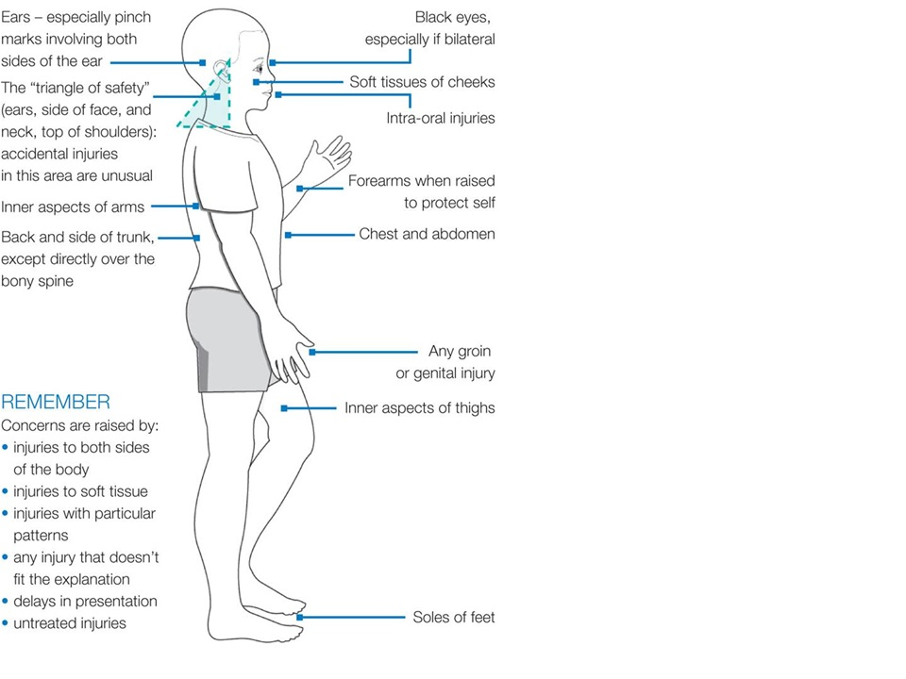 | 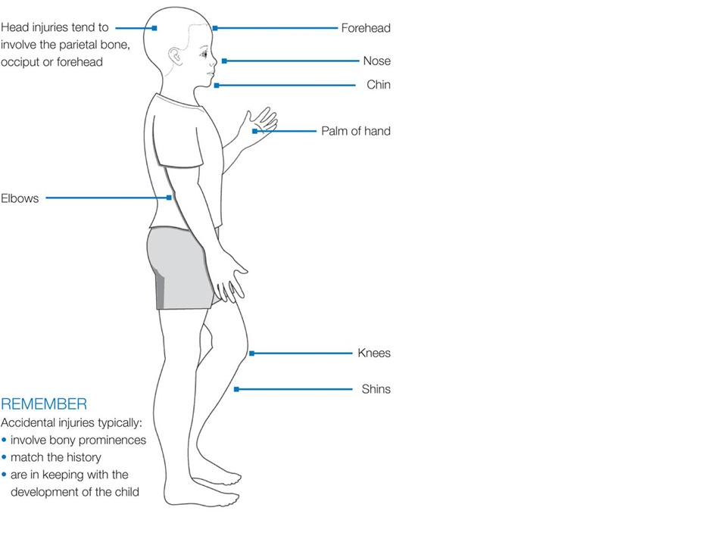

Neglect
Neglect is the persistent failure to meet a child’s basic physical and/or psychological needs, likely to result in the serious impairment of the child’s health or development. Neglect may occur during pregnancy as a result of maternal substance abuse. Once a child is born, neglect may involve a parent or carer failing to:
- provide adequate food, clothing and shelter (including exclusion from home or abandonment);
- protect a child from physical and emotional harm or danger;
- ensure adequate supervision (including the use of inadequate care-givers)
- ensure access to appropriate medical care or treatment.
It may also include neglect of, or unresponsiveness to, a child’s basic emotional needs.

Signs that may indicate neglect
- Excessive hunger
- Poor personal hygiene
- Frequent tiredness
- Inadequate clothing
- Frequent lateness or non attendance at school
- Untreated medical problems
- Poor relationship with peers
- Compulsive stealing and scavenging
- Rocking, hair twisting and thumb sucking
- Running away
- Loss of weight or being constantly underweight (the same applies to weight gain, or being excessively overweight)
- Low self esteem
- Poor dental hygiene.

Emotional abuse
Emotional abuse is the persistent emotional maltreatment of a child such as to cause severe and persistent adverse effects on the child’s emotional development.
It may involve conveying to children that they are worthless or unloved, inadequate, or valued only insofar as they meet the needs of another person. It may include not giving the child opportunities to express their views, deliberately silencing them or ‘making fun’ of what they say or how they communicate.
It may feature age or developmentally inappropriate expectations being imposed on children. These may include interactions that are beyond the child’s developmental capability, as well as overprotection and limitation of exploration and learning, or preventing the child participating in normal social interaction.
It may involve seeing or hearing the ill-treatment of another.
It may involve serious bullying (including cyber bullying), causing children frequently to feel frightened or in danger, or the exploitation or corruption of children.
Some level of emotional abuse is involved in all types of maltreatment of a child, though it may occur alone.

Signs that may indicate emotional abuse
- Over reaction to mistakes
- Lack of self confidence / esteem
- Sudden speech disorders
- Self harming
- Extremes of passivity and /or aggression
- Compulsive stealing
- Drug, alcohol, solvent abuse
- Fear of parents being contacted
- Unwillingness or inability to play
- Excessive need for approval, attention and affection.

Section 4

STAFF PROTECTION

A special feature of St. Clare's is its relaxed and informal atmosphere. Wardens and teachers fulfil many roles, not least that of temporary parent. Given the risk, however slight, of teenage confusion about their roles leading to imagined offences, staff must ensure that their behaviour and actions do not place themselves or students at risk of harm or of allegations of harm to a student.

Staff should bear in mind the following points:

- Private one-to-one meetings with students in your own home or at social events outside the college are prohibited. Obviously this does not apply to Wardens talking to students in their houses or to teachers talking to students in the non-residential areas of the college, though it would be prudent to have another person present even in a "public" area if the matter under discussion is serious or very delicate.

- If you have a serious disagreement with a student, make a brief written record of it and pass this to your line manager.

- The students' bedrooms are private areas and only residential, cleaning and maintenance staff, as well as Senior Management (or those given express permission by a member of the SMG) can access those areas in connection with the fulfilment of their duties.

- Staff in charge of activities or facilities where safety regulations and precautions are required must make sure that these are clearly published and should draw students' attention to them from time to time. Any accidents or unusual incidents should always be recorded on the College’s accident/incident form.

- All staff should be acquainted with the following documents, copies of which are on the intranet.

  - College Regulations
  - Complaints Procedure
  - Trips Policy

Most recent review and/or amendment
TW March 2013

Annex 1 of Child Protection Policy

Dealing With Allegations of Abuse Against Members of Staff

This policy is about managing allegations that might indicate that a person is unsuitable to continue to work with children in their present position, or in any capacity. It is drawn from and is consistent with Department for Education guidance issued in July 2011: Dealing With Allegations of Abuse Against Teachers and Other Staff.
The policy should be used where it is alleged that a member of staff has:
- behaved in a way that has harmed a child, or may have harmed a child;
- possibly committed a criminal offence against or related to a child; or
- behaved towards a child or children in a way that indicates s/he would pose a risk of harm if they work regularly or closely with children.
Any allegation of abuse made against a teacher or other member of staff must be dealt with quickly, fairly and consistently so that effective protection is provided for the child and support for the person who is the subject of the allegation.

- Allegation made to school
The allegation should be reported to the Principal immediately unless the allegation is about the Principal in which case it should be reported to the chair of governors (see Section 2 point 9 above for further guidance).
If the allegation meets the criteria above, the Principal should report it to the local authority designated officer (LADO) the same day. The LADO for Oxfordshire is Mr Barry Armstrong (01865 810603). The LADO has overall responsibility for oversight of the procedures for dealing with allegations and for providing advice and guidance to the College.

- Initial consideration
The local authority designated officer will discuss the matter with the Principal and where necessary obtain further details of the allegation and the circumstances in which it was made. The Principal will not investigate the allegation at this stage. The discussion should also consider whether there is evidence or information that establishes that the allegation is false or unfounded.

If the allegation is not clearly false and there is cause to suspect that a child is suffering or is likely to suffer significant harm, the local authority designated officer will immediately refer to children’s social care and ask for a strategy discussion in accordance with Working Together to Safeguard Children to be convened straight away. In those circumstances the strategy discussion should include the local authority designated officer and the Principal.

If there is not cause to suspect that “significant harm” is an issue, but a criminal offence might have been committed, the local authority designated officer should immediately inform the police and convene a similar discussion to decide whether a police investigation is needed. That discussion should also involve the school and any other agencies involved with the child.

- Action following initial consideration
Where the initial consideration decides that the allegation does not involve a possible criminal offence it will be for the employer to deal with it. In such cases, if the nature of the allegation does not require formal disciplinary action, the Principal should institute appropriate action. If a disciplinary hearing is required and can be held without further investigation, the hearing should be held in accordance with St. Clare’s disciplinary policy.

If a criminal investigation is required: (i) if the police decide not to charge the individual with an offence, or decide to administer a caution, or the person is acquitted by a Court, the police should wherever possible aim to pass all information they have which may be relevant to a disciplinary case to the school within three working days of the decision, (ii) if the person is convicted of an offence the police should also inform the employer straight away so that appropriate action can be taken.

The following timescales should apply:
- Unfounded or malicious allegation – should be resolved within 1 week
- No criminal offence; employer to deal with; concerns about child protection
  - No formal disciplinary action – Principal institutes action within 3 working days
  - Disciplinary hearing required, but no further investigation – hearing within 15 working days.

Information should be shared between the College and the police and social services at the initial strategy discussion. Subsequently should there be police or social services investigations, each agency should share information with the College.

- Suspension
The possible risk of harm to children posed by an accused person needs to be effectively evaluated and managed in respect of the child(ren) involved in the allegations.
Suspension must not be an automatic response when an allegation is reported.
Suspension should only be considered in any case where there is cause to suspect a child is at risk of significant harm, or the allegation warrants investigation by the police, or is so serious that it might be grounds for dismissal. However, a person must not be suspended automatically, or without careful thought. Alternative arrangements such as redeployment should be considered.
The final decision regarding suspension rest with the Principal and Governing Body.

- Resignations and Compromise Agreements
The fact that a person tenders his or her resignation, or ceases to provide their services, must not prevent an allegation being followed up in accordance with these procedures. It is important that every effort is made to reach a conclusion in all cases of allegations bearing on the safety or welfare of children, including any in which the person concerned refuses to
cooperate with the process. Wherever possible, the person should be given a full opportunity to answer the allegation and make representations about it, but the process of recording the allegation and any supporting evidence, and reaching a judgement about whether it can be
regarded as substantiated on the basis of all the information available, should continue even if that cannot be done or the person does not cooperate. It may be difficult to reach a conclusion in those circumstances, and it may not be possible to apply any disciplinary sanctions if a person’s period of notice expires before the process is complete, but it is important to reach and record a conclusion wherever possible.

So called “compromise agreements” by which a person agrees to resign and a school agrees not to pursue disciplinary action, and both parties agree a form of words to be used in any future reference, must not be used in these cases.

- Action on conclusion of a case
If the allegation is substantiated and the person is dismissed or the College ceases to use the person’s services, or the person resigns, the school should consult the local authority
designated officer about whether a referral to the Disclosure and Barring Service (DBS) is required. If a referral is appropriate the report should be made within one month.
There is a legal obligation to make a referral if St. Clare’s considers that an individual has engaged in conduct that has harmed a child or if a person otherwise poses a risk of harm to a child.
In cases where it is decided on the conclusion of the case that a person who has been suspended can return to work consideration must be given to how best to facilitate that. Most people will benefit from some help and support to return to work after a very stressful
experience. Depending on the individual’s circumstances, a phased return and/or the
provision of a mentor to provide assistance and support in the short term may be appropriate. Consideration must be given to how the person’s contact with the child or children who made the allegation can best be managed if they are still attending the school.

- Record Keeping
Details of allegations that are found to have been malicious should be removed from personnel records. For all other allegations it is important that a clear and comprehensive summary of any allegations made, details of how the allegation was followed up and resolved, and a note of any action taken and decisions reached, is kept on a person’s confidential personnel file, and a copy provided to the person concerned. The purpose of the record is to enable accurate information to be given in response to any future request for a reference if the person has moved on. It will provide clarification in cases where a future CRB Disclosure reveals information from the police about an allegation that did not result in a criminal conviction. And it will help to prevent unnecessary reinvestigation if, as sometimes happens, an allegation re-surfaces after a period of time. The record should be retained at least until the person has retired or for a period of 10 years from the date of the allegation if that is longer.

- Action in respect of False Allegations
If an allegation is determined to be false or malicious, the LADO should refer the matter to children’s social care to determine whether the child concerned is in need of services, or may have been abused by someone else. In the event that an allegation is shown to have been deliberately invented or malicious, the Principal should consider whether any disciplinary action is appropriate against the student who made it, or the police should be asked to consider whether any action might be appropriate against the person responsible if s/he was not a student.
References - cases in which an allegation(s) was proven to be unsubstantiated, unfounded or malicious should not be included in employer references.

- Supporting those involved
Parents or carers of a child or children involved should be told about the allegation as soon as possible if they do not already know of it, unless it would compromise the safety of the child. They should also be kept informed about the progress of the case, and told the outcome where there is not a criminal prosecution, including the outcome of any disciplinary process. Please note that the deliberations of a disciplinary hearing, and the information taken into account in reaching a decision, cannot normally be disclosed, but the parents or carers of the child should be told the outcome.

In cases where a child may have suffered significant harm, or there may be a criminal prosecution, children’s social care, or the police as appropriate, should consider what support the child or children involved may need.

The person who is the subject of the allegations should be kept informed of the progress of the case and consideration must be given to what other support is appropriate for the individual. If the person is suspended, the individual should be kept informed about developments at school – a named representative should be appointed by the school to do this. If the person is a member of a union or professional association s/he should be advised to contact that body at the outset.

- Confidentiality
Every effort should be made to maintain confidentiality and guard against unwanted publicity while an allegation is being investigated or considered.

- Further Guidance
The framework for managing cases of allegations of abuse against people who work with children is set out in ‘Working together to safeguard children: a Guide to inter-agency working to safeguard and promote the welfare of children’ (March 2010).

